1)

**AIM** :

Create a JavaScript code to generate a multiplication table asking the user to enter number of rows and columns. Use JavaScript function.

**DESCRIPTION** :

JavaScript is the world's most popular programming language.

JavaScript is the programming language of the Web.

JavaScript is easy to learn.

Window object that models the browser window.

Window object includes three methods that create dialog boxes.

The prompt() method displays a dialog box that prompts the user for input.

The prompt() method returns the input value if the user clicks "OK", otherwise it returns null.

A piece of code executed repeatedly in an application, separate that code as function and call whenever required.

A function is written as a code block (inside curly { } braces), preceded by the function keyword.

document.write- function can be

used to write text, XHTML elements , or both

**PROGRAM CODE** :

<!DOCTYPE html>

<html lang="en">

<head>

<meta charset="UTF-8">

<meta http-equiv="X-UA-Compatible" content="IE=edge">

<meta name="viewport" content="width=device-width, initial-scale=1.0">

<title>Multiplication Table</title>

<script>

var rows=prompt("Enter the number of rows required in the multiplication table : ");

var columns=prompt("Enter the number of columns required in the multiplication table : ");

if(rows==null||rows==""){

rows=10;

}

if(columns==null||columns==""){

columns=10;

}

document.write("<h1 align='center'>Multiplication Table</h1>")

createTable(rows,columns);

function createTable(rows,columns){

document.write("<center>")

document.write("<table cellpadding=20 cellspacing=10 border=2>")

for(var i=1;i<=rows;i++){

var j=1;

document.write("<tr>");

while(j<=columns){

document.write("<td>"+(i*j)+"</td>")

j++;

}

document.write("</tr>")

j=1;

}

document.write('</table>')

document.write("</center")

}

</script>

</head>

<body>

</body>

</html>

**OUTPUT** :

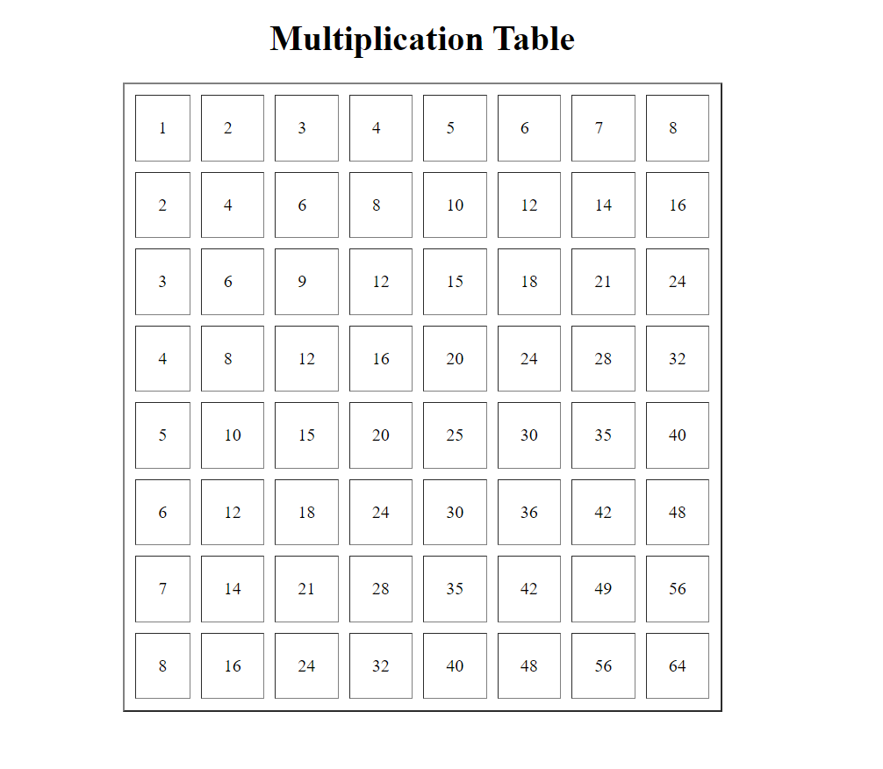

**RESULT ANALYSIS** :

Learnt how JavaScript can be used to add interactivity to the web page , take input from the user using prompt() , and add html elements using JavaScript.

2)

**AIM :**

Design a scientific calculator using javascript

**DESCRIPTION :**

Dom acts as interface between HTML, CSS and Javascript

Using DOM javascript communicate with HTML and CSS

When html page is loaded browser will create DOM. All html elements stored as javascript objects

Methods to access html elements :

document.getElementById(Id) – Find elements by id.

document.getElementsByTagName(name) – Returns list of all elements with the specified tag.

document.get ElementsByClassName(name) – Returns list of all elements which belong to same class

document.querySelector(name of selector) – returns first matched CSS selector.

document.querySelectorAll(all) -- Returns all objects matched with CSS selector.

**CODE :**

<!DOCTYPE html>

<html lang="en">

<head>

<meta charset="UTF-8">

<meta http-equiv="X-UA-Compatible" content="IE=edge">

<meta name="viewport" content="width=device-width, initial-scale=1.0">

<title>Calculator</title>

<style>

#box{

width: 500px;

height: 20px;

align-self: center;

}

td{

width: 100px;

}

td button{

width: 100px;

height: 50px;

color: blue;

font-size: 25px;

}

</style>

<script src="cal.js"></script>

</head>

<body>

<h1 align="center">Calculator</h1>

<table cellpadding="20" cellspacing="2" border="2" align="center">

<tr>

<td colspan="5" id="one">

<input type="text" name="" id="box">

</td>

</tr>

<tr>

<td><button value="1" onclick="fillBox('1')">1</button></td>

<td><button value="2" onclick="fillBox('2')">2</button></td>

<td><button value="3" onclick="fillBox('3')">3</button></td>

<td><button value="+" onclick="fillBox('+')">+</button></td>

</tr>

<tr>

<td><button value="4" onclick="fillBox('4')">4</button></td>

<td><button value="5" onclick="fillBox('5')">5</button></td>

<td><button value="6" onclick="fillBox('6')">6</button></td>

<td><button value="-" onclick="fillBox('-')">-</button></td>

</tr>

<tr>

<td><button value="7" onclick="fillBox('7')">7</button></td>

<td><button value="8" onclick="fillBox('8')">8</button></td>

<td><button value="9" onclick="fillBox('9')">9</button></td>

<td><button value="" onclick="fillBox('*')">*</button></td>

</tr>

<tr>

<td><button value="=" onclick="document.getElementById('box').value=eval(document.getElementById('box').value)">=</button></td>

<td><button value="C" onclick="document.getElementById('box').value=''">C</button></td>

<td><button value="0" onclick="fillBox('0')">0</button></td>

<td><button value="/" onclick="fillBox('/')">/</button></td>

</tr>

</table>

</body>

</html>

cal.js

function fillBox(val){

document.getElementById('box').value+=val;

}

**OUTPUT :**

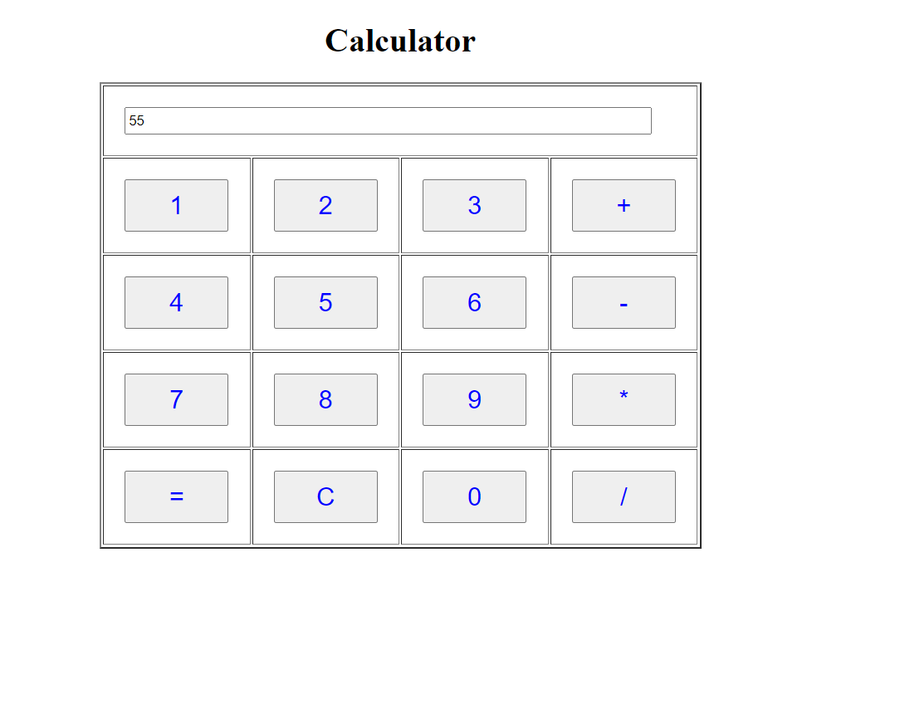

**RESULT ANALYSIS :**

Understood about the tag attributes that is added along with the tag, also extract the input and evaluate the sting using eval expression, also calling functions to append the numbers to the sting and at last providing arguments to the function.

3)

**AIM :**

Create a JavaScript code to display the following table to order Pizza & on clicking confirm order following pop up box should get displayed

**DESCRIPTION :**

Java script detect certain events performed on the browser and browser user and provide computation reactions when event occurred.

These computations are called event driven programming.

Event is generate when user clicks on any html element with which java script should react.

element.value is used to extract the user input value.

onclick tag attribute is used to specify an event when the user clicks on the it.

parseInt() is used to extract integer value from, ie, converting string to integer.

element.innerHTML is used to change the HTML content.

**CODE :**

<!DOCTYPE html>

<html lang="en">

<head>

<meta charset="UTF-8">

<meta http-equiv="X-UA-Compatible" content="IE=edge">

<meta name="viewport" content="width=device-width, initial-scale=1.0">

<title>Pizza Order Form</title>

<script>

function calCost() {

var cost1 = document.getElementById('cpiz').value;

var cost2 = document.getElementById('ppiz').value;

var cost3 = document.getElementById('vpiz').value;

if(cost1==null||cost1==""){

cost1="0"

document.getElementById('cpiz').value="0"

}

if(cost2==null||cost2==""){

cost2="0"

document.getElementById('ppiz').value="0"

}

if(cost3==null||cost3==""){

cost3="0"

document.getElementById('vpiz').value="0"

}

var price1=document.getElementById('price1').innerHTML;

var price2=document.getElementById('price2').innerHTML;

var price3=document.getElementById('price3').innerHTML;

var totalcost = parseInt(cost1)*parseInt(price1) + parseInt(cost2)*parseInt(price2) + parseInt(cost3)*parseInt(price3);

document.getElementById('totalcost').value= totalcost;

}

function cancelOrder(){

document.getElementById('cpiz').value="";

document.getElementById('ppiz').value="";

document.getElementById('vpiz').value="";

document.getElementById('totalcost').value="";

}

function confirmOrder(){

confirm("Your order will be ready by 10 minutes");

document.getElementById('cpiz').value="";

document.getElementById('ppiz').value="";

document.getElementById('vpiz').value="";

document.getElementById('totalcost').value="";

}

</script>

</head>

<body>

<h1>Pizza Order Form</h1>

<table cellpadding="20" cellspacing="2" border="2">

<tr>

<th>Item Name</th>

<th>Price</th>

<th>Quantity</th>

</tr>

<tr>

<td>Chicken Pizza</td>

<td id="price1">100</td>

<td><input type="text" name="" id="cpiz"></td>

</tr>

<tr>

<td>Paneer Pizza</td>

<td id="price2">80</td>

<td><input type="text" name="" id="ppiz"></td>

</tr>

<tr>

<td>Veg Pizza</td>

<td id="price3">70</td>

<td><input type="text" name="" id="vpiz"></td>

</tr>

</table>

<br>

<button onclick="calCost()">Total Cost</button>

<input type="text" name="" id="totalcost">

<br>

<br>

<button onclick="confirmOrder()">Confirm Order</button>

<button onclick="cancelOrder()">Cancel Order</button>

</body>

</html>

**OUTPUT :**

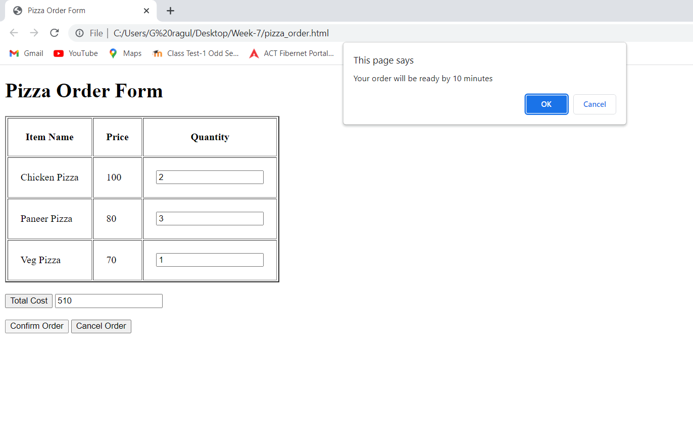

**RESULT ANALYSIS :**

Used the parseInt() function to convert string to integer, calculate the values by extracting from the input text boxes and assigning it to another text box and finally calling alert() , after the button is clicked.